**Beneficiary Analysis**

**for the**

**Town Hall of Tîrgu Neamț**

**Activity Profile**: Administration

**Address:** Bulevardul Stefan cel Mare nr.62, Targu Neamt

**Phone:** 0233.790245

**Organisational structure and employees:**

|  |  |  |  |  |  |  |  |  |
| --- | --- | --- | --- | --- | --- | --- | --- | --- |
| **Specialitate** | **Functie** | | | | | **Angajati** | **Total Angajati** | |
| **Aparatul de specialitate al primarului** | 2 demnitari (*primar+viceprimar*) | | | | | **102** | | **174** |
| 1 administrator public | | | | |
| 99 functii publice | | | | 1 secretar general |
| 11 functii de conducere |
| 87 functii de executie |
| **Centrul de informare si promovare turistica** | 2 functii contractuale | | | | | **2** | |
| **Biblioteca** | 4 posturi contractuale | | | | | **4** | |
| **Casa culturii** | 8 functii contractuale | | | | | **8** | |
| **Serviciul administrative gospodaresc** | 13 functii contractuale | | | | | **13** | |
| **Politia locala** | 18 functionari publici | | 1  functie publica de conducere | | 4  functii de natura contractuala | **22** | |
| 17 functii publice de executie | |
| **Serviciul Public Comunitar Local de Evidenta a Persoanei** | 16  functionari publici | 2  functii de conducere | | 2  functii de natura contractuala | | **18** | |
| 14  functii de executie | |
| **Serviciul Voluntari Pentru Situatii de Urgenta** | 3 functii contractuale | | | | | **3** | |
| **Cabinetul primarului** | 2 functii contractuale(2 consilieri) | | | | | **2** | |
|  |  |  |  |  |  |  |  |  |

*Table 1: Employees*

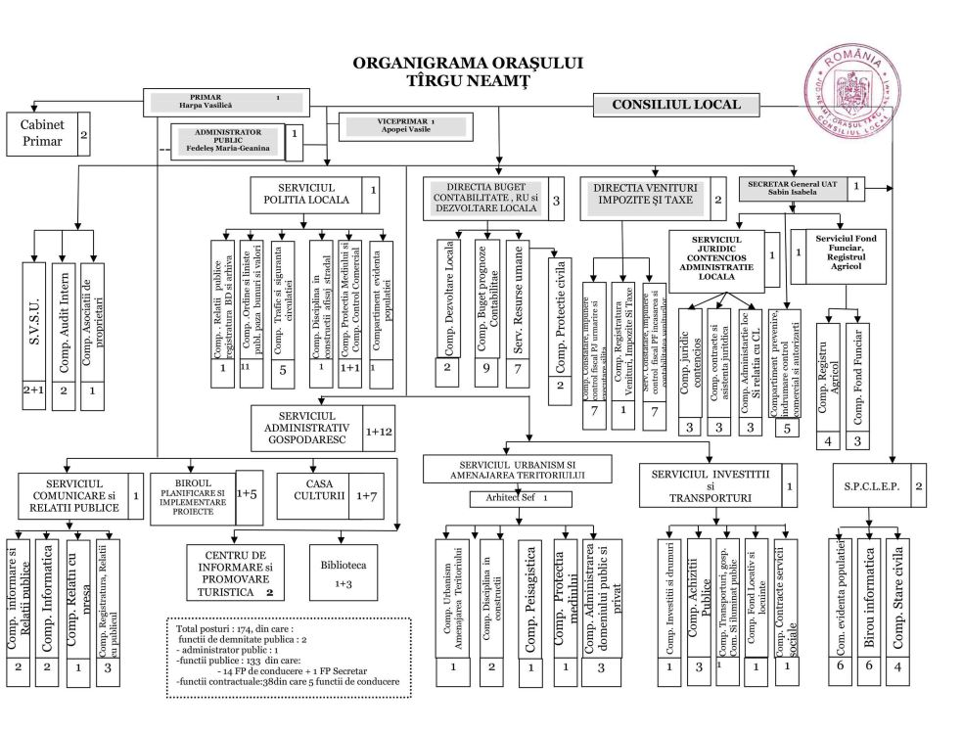

*Image 1: Organisational structure*

**Building Analysis**

**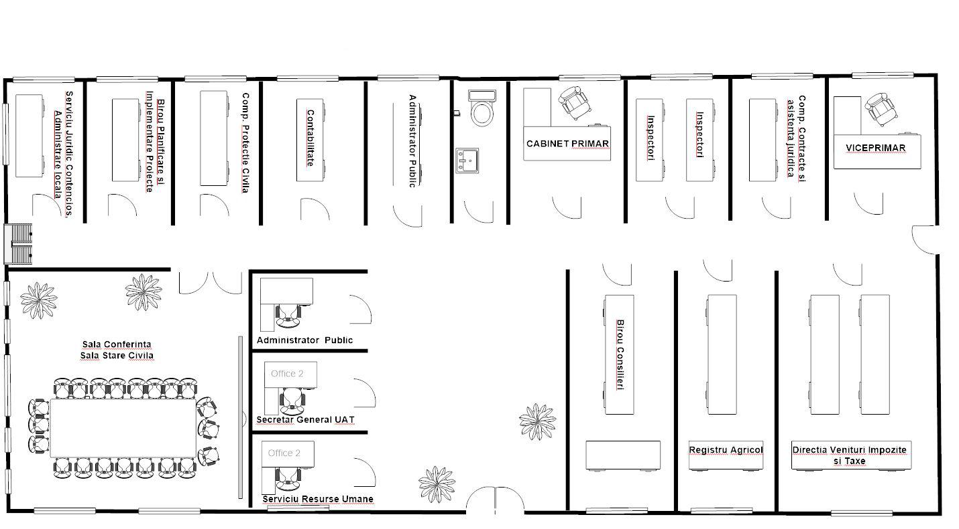***Image 2: Ground Floor*

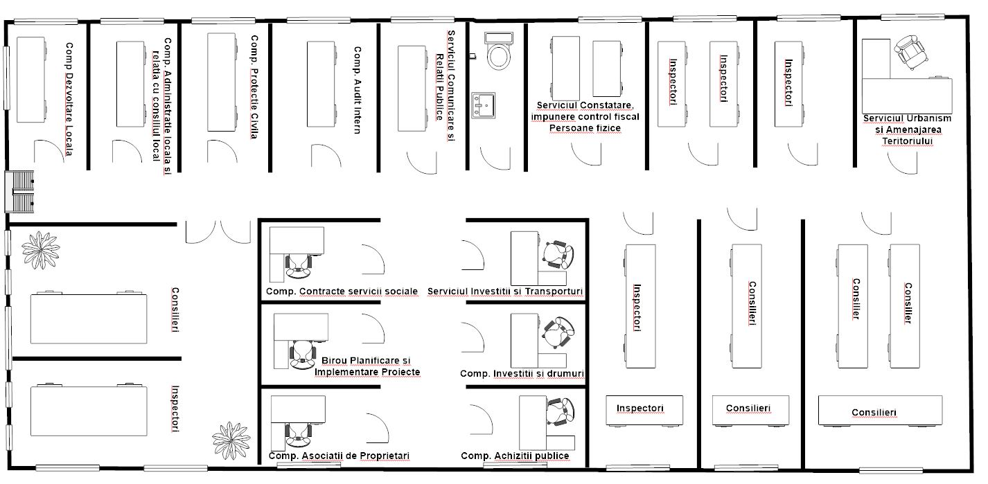

*Image 3: First Floor*

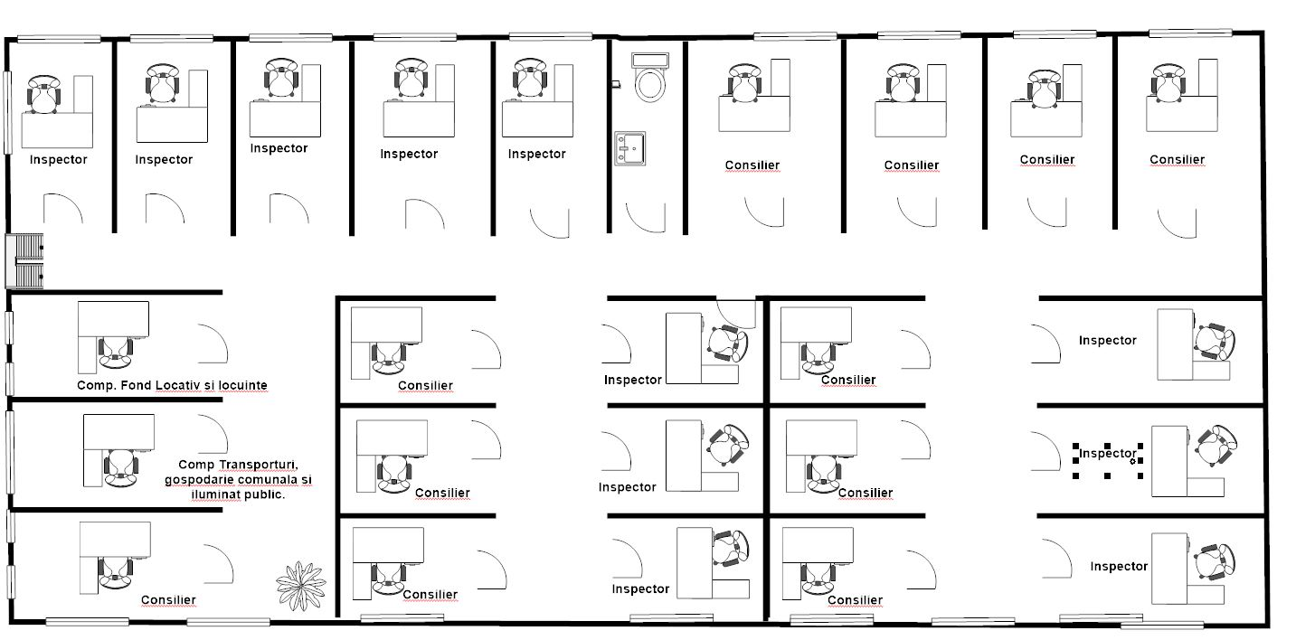

*Image 4: Second Floor*

**Ground Floor**

* Conferince Hall
* Administration Office
* Secretary Office
* Human Resourse Service Office
* Counselours Office
* Agriculture Register Office
* Taxes Office
* Deputy office
* Mayor office
* Inspectors Office
* Public Administrators Office
* Contability Office
* Toilet
* Civil Protection Office
* Planning and Implementing Projects Office
* Local Administration Office

**First Floor**

* **3** Counselours Offices
* **4** Inspectors Offices
* Local Development Office
* Local Administration and the relation with the local Council Office
* Civil Protection Office
* Intern Audit Office
* Communication service and Public Relations Office
* Observation service Office
* Urban planning and spatial planning Office
* Toilet
* Investitions and transport service Office
* Investitions and roads Office
* Public Procurement Office
* Property Associations Office
* Planning and Implementing Office
* Social contracts services Office

**Second Floor**

* ***11*** Counselours Office
* ***11*** Inspectors Office
* Housing stock
* Transport, communal household and public lighting
* Toilet

**Development Plan**: none for the next 5 years

**Special conditions:** secured, private and stable network